Product-wise Sales Comparison Report
02 August 2025
Prepared by Sales Team

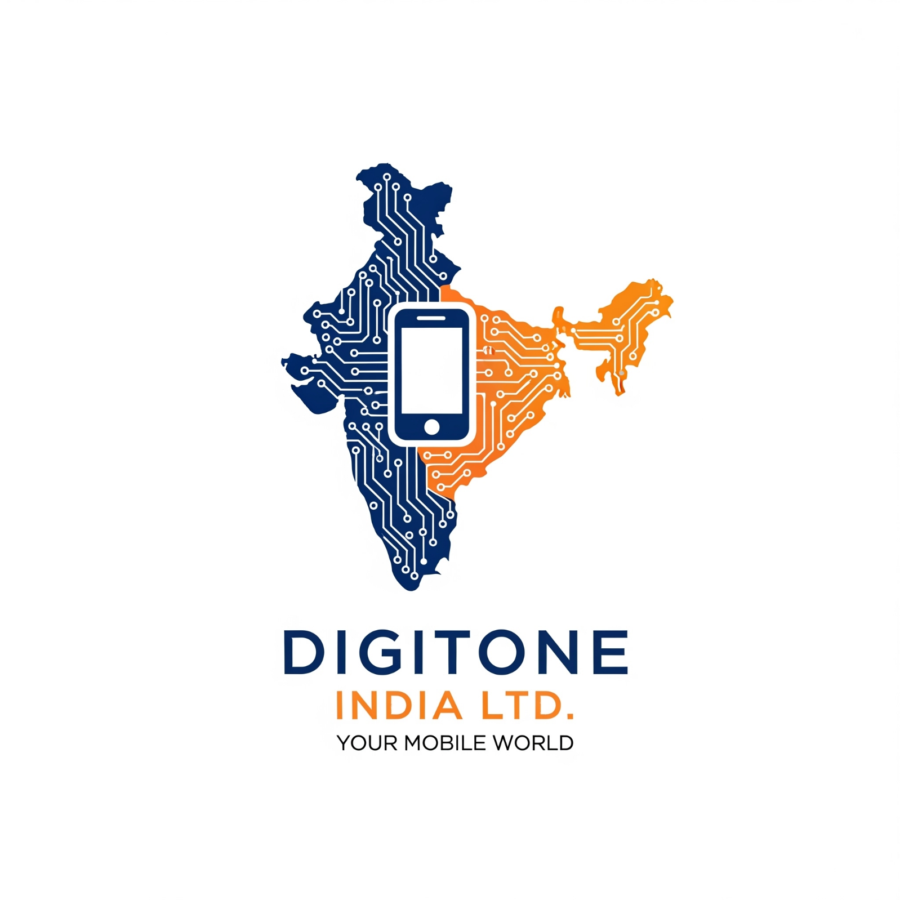

Introduction
This Report compares the sales performance of Zeniva Z12 Ultra, Nexora Edge 5G, Digitone Phantom 11, for the Q2 and Q1 2025. The objective is to analyse sales trends, identify top-performing products and provide recommendations for improving sales strategies.

Sales Data
Product Name | Q1 Sales (₹) | Q2 Sales (₹) | % Change
Zeniva Z12 Ultra | 872029.65 | 1046435.58 | +20.00
Nexora Edge 5G | 1308044.47 | 1133638.54 | -13.33
Digitone Phantom 11 | 697623.72 | 828428.17 | 18.75
Figure A: Quarterly Comparison by Product

Analysis
- The Nexora Edge 5G had the highest total sales, while the Zeniva Z12 Ultra showed the most growth at 20%.
- The Nexora Edge 5G showed the most decline at -13.33%.

Recommendations
- Increase marketing efforts for underperforming products.
- Focus on high-performing products for expansion (Zeniva Z12 Ultra).
- Investigate reasons for sales decline in Nexora Edge 5G.

